30. Assign a design to the website in AEM (Client library step 4)

Go the site console and select our we train website, go to view properties.

Click on advanced tab, select our design in the design tab which we have created in client library step 1. click on save and close it.

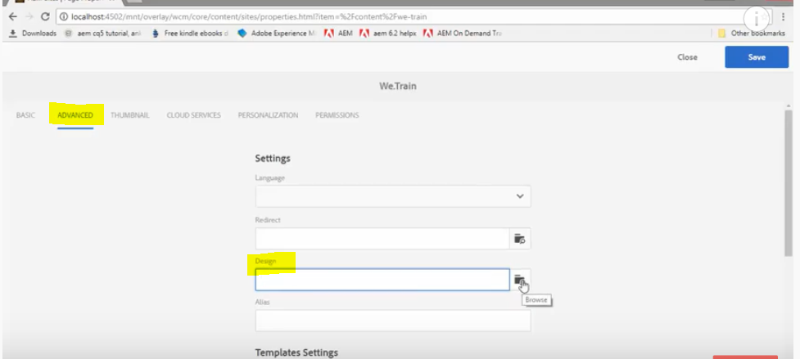

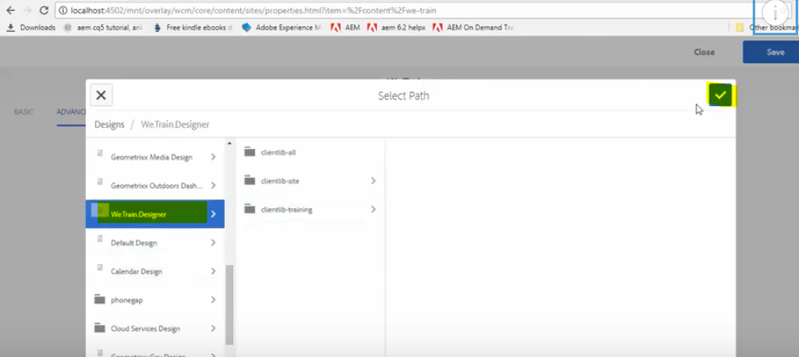

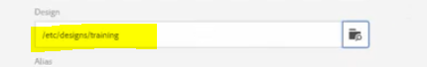

Now open the English page, notice that English page has inherited the design from the Wee.

Train website root. Now each page in the website is using the newly defined page.

